Allied School Al-Rehman Campus Allied School Al-Rehman Campus Allied School Al-Rehman Campus
Okara Okara Okara
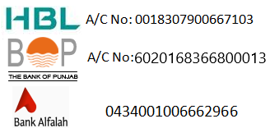 |  |  |  |  |  | 
Sr. No.: |  |  | Sr. No.: |  |  | Sr. No.:
Name: |  |  | Name: |  |  | Name:
Father Name: |  |  | Father Name: |  |  | Father Name:
Class: |  |  | Class: |  |  | Class:
Annual subscription 2026 |  |  | Annual subscription 2026 |  |  | Annual subscription 2026
Arrears: |  |  | Arrears: |  |  | Arrears:
Monthly fee for June: |  |  | Monthly fee for June: |  |  | Monthly fee for June:
Payable by Due Date: |  |  | Payable by Due Date: |  |  | Payable by Due Date:
Payable After Due Date: |  |  | Payable After Due Date: |  |  | Payable After Due Date:
Fee for: June 2026- June 2026 Fee for: June 2026- June 2026 Fee for: June 2026- June 2026
Bank copy Campus copy Student copy
Due date: 10-06-2026 Due date: 10-06-2026 Due date: 10-06-2026
Principal: Principal: Principal:
Note:- Note:- Note:-
->The fee be deposited in the ->The fee be deposited in the ->The fee be deposited in the
Designated Bank. Designated Bank. Designated Bank.
->The challan must be deposited within due ->The challan must be deposited within due ->The challan must be deposited within due
date to avoid late payment charges. date to avoid late payment charges. date to avoid late payment charges.
-> New challan issuance charges Rs:10/. -> New challan issuance charges Rs:10/ -> New challan issuance charges Rs:10/

